Task 1:Create a Directory with the Name Linux Practice.

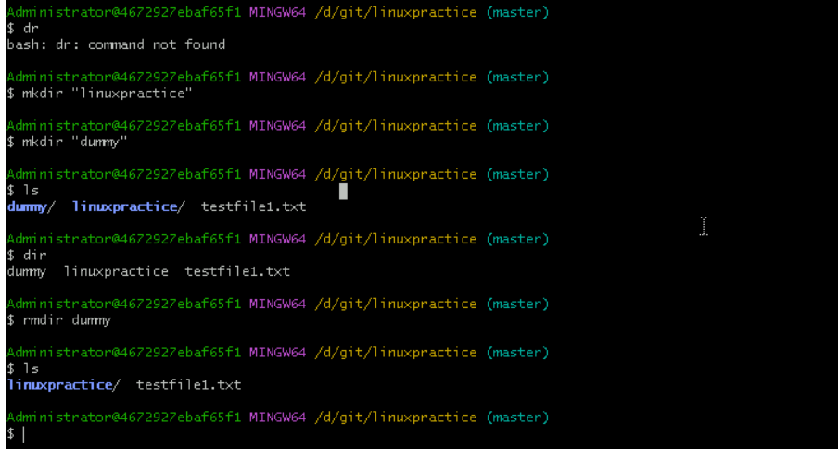

Task 5:

Plz check the working directory (Hint : pwd)

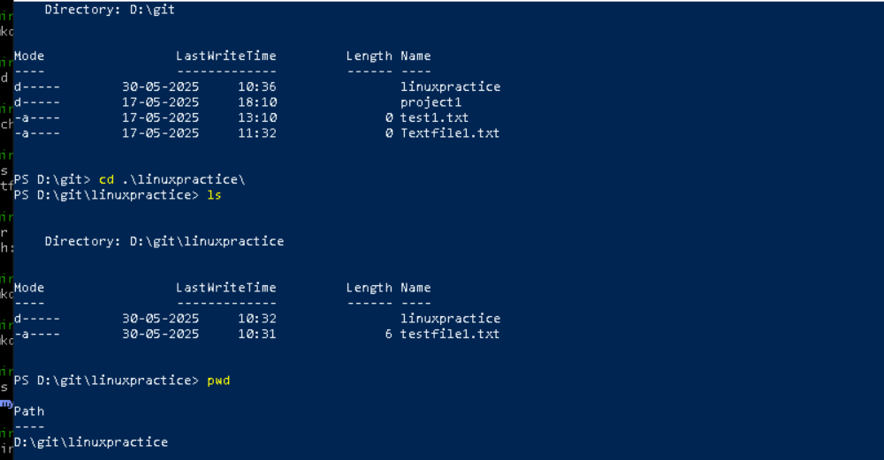

Task 6:

How do you check all the files and directories in the directory you are in?



Task 7:

Create five files named TestFile2.txt.. TestFile3.txt… and so on till TestFile6.txt

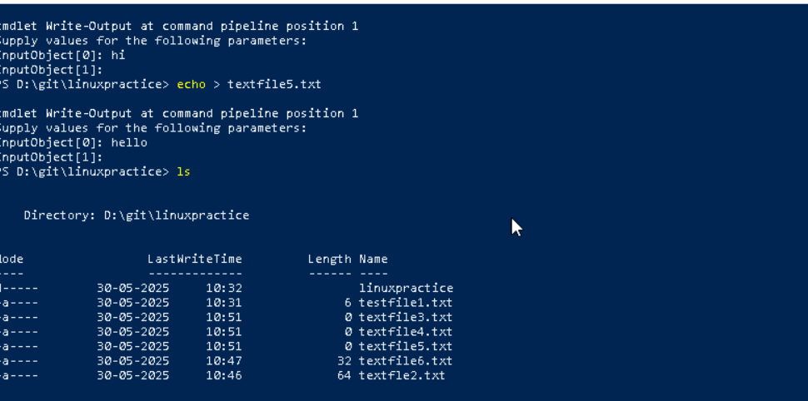

Task 8:

Copy all files from Dir 1 ti Dir 2

2 min

Task 9:

Move all files from Dir 2 to Dir 3 (finally ur Dir 2 should be empty)

3 min

Task 10:

Can you plz show me the diff between **rm** and **rmdir** commands with screen shots ?

5 min

Task 11:

Now use specifically use cat command to create a file

And add the dummy text of 2 to 3 paragraphs from the above link Lorem Ipsum.

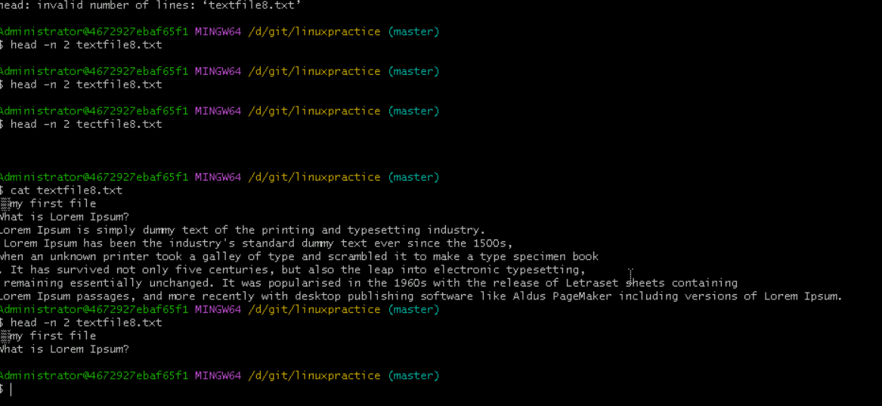

Task 12:

How to get only the top part of your file..

Hint: use head

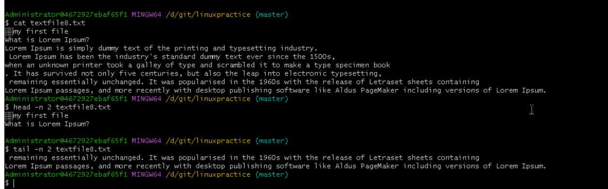

Task 13:

How to get only the last part of your file

Hint: use tail



Task 14:

Plz add dummy text of 5 to 6 pages in to the same file

And

Now show the file in page by page

Hint : use less command

 10 min

Task 15:

Use more command on the above file and find out the diff between less command and more command.

 5 min

What is e in echo command..?

The e in the echo command is an option that enables the interpretation of backslash escape sequences. These sequences allow you to insert special characters and formatting into the output.

Task 16:

Can you use echo command with -e and see the diff.. Also take a ss and paste .

 4 min

Task 17:

What is diff between ls and ls -l command .. ss plz

5 min

Task 18:

Create  a file using **touch** command , **cat** command and **echo** command and take ss (screen shot)..

Also write the difference between touch , cat and echo commands.

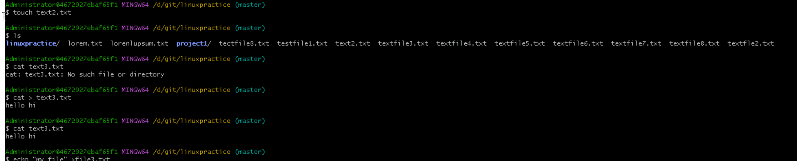

Task 19:

Can you guys try to display the calendar by using a command..

Hint: use cal

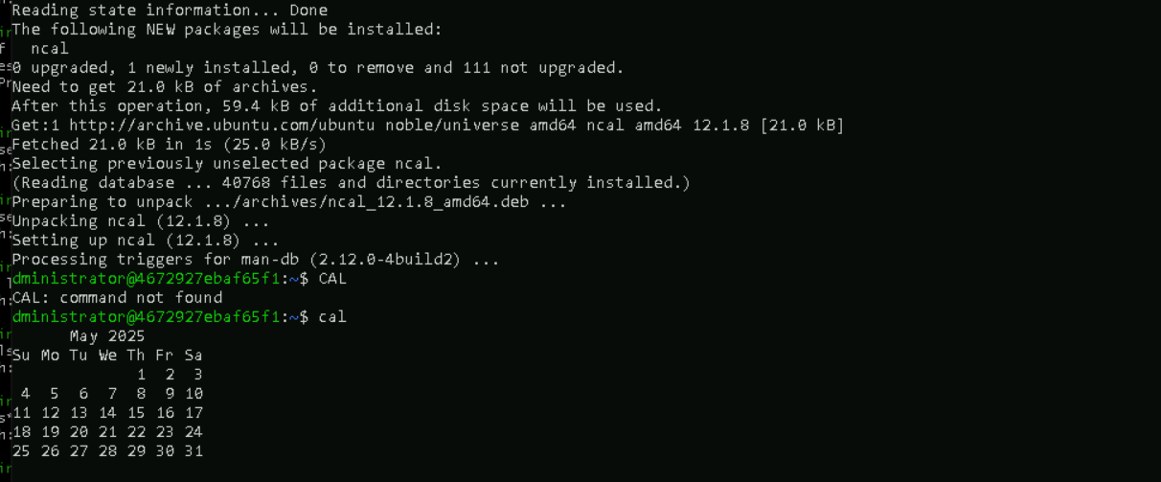

Task 20:

Can you go back to 1 directory .. at a time  whats the command

2 min

Task 21:

How to know whose user u are working on ?

Hint: use whoami command

2 min

Task 22:

Try to find out who is peeping into your system..

Hint: Use users, who and w commands with ss

10 min

Task 23:

Can you guys try to check how much disk space is consumed..

Hint : use df -h

Task 24:

In the **ls -l** listing example, every file line begins with a **d**, **-**, or **l**. These characters indicate the type of the file that's listed.

Can you plz try using the below commands

Task 25:

Find the list pf all files ending with .txt

Hint : use * in ls

2 min

Task 26:

In Linux all the hidden files starts with . (period)

How to check all the hidden files in Linux..

Hint : use  ls -a

Task 27:

What is the difference between . and .. in linux

Line 1 line for each

Task 28:

Can you create a file using vi editor and show the details in ss

Hint:

 Esc is for come out of the edit mode

Press two keys Shift &plus; ZZ together to come out of the file completely

Task 29:

How to find the no of words in the file

Hint: use wc

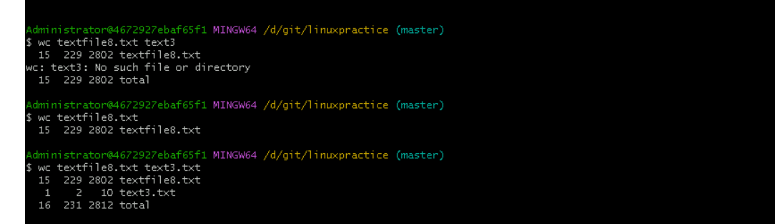

Task 30:

What is the use of cat -b myfilename.txt command?

Ans : Count the no of lines in the file

Task 31:

Can I use the wc with 2 or more files?



Task 32:

How to copy content of one file to another file

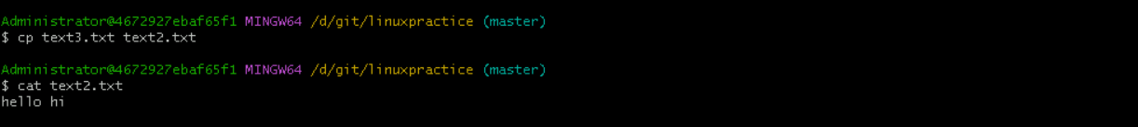

Task 33:

Now I want to rename my file with MYFILENEW can i do that if so how ?

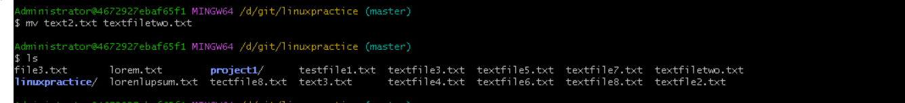

Task 34:

Can i remove or delete multiple files in linux..? How?

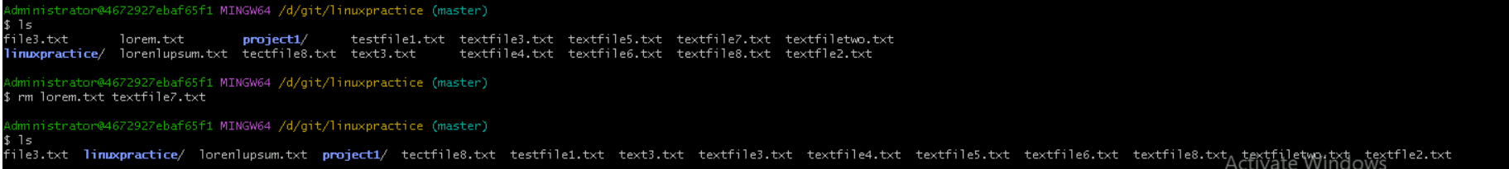

Task 35:

In directory / slash is root  …  can you try cd / what is it doing?

**Ans : slash /** represents the **root directory**, which is the **top-level directory** in the file system hierarchy.



Linux directory structure: plz have a reading and try to remember..

Task 36:

What is the way go go to home directory ?

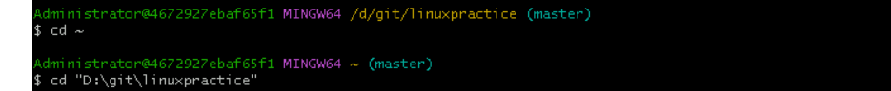

Task 37:

If i want to move to different users home directory

Hint : use ~username

16.30 to 16.35

Task 38:

Chmods: